1.What is JMeter distributed mode?
There are certain limitations to the number of users you can run, with the CPU, Memory and RAM Configuration for a single machine.
Example: If we want to run a specific function with 5000 users then your system may slow due to its configurations hence it may lead to generate incorrect output or test case may fail sometimes to avoid this will use JMeter distribution slaves where we can create 5 slaves and will assign 1000 users to each slave so that will get exact output and here, we are going to hit server with 5000 users at a time.
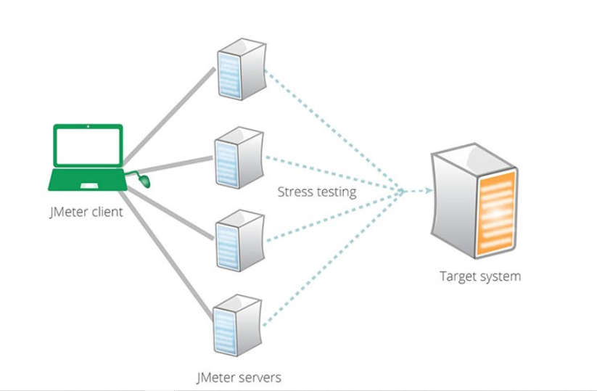
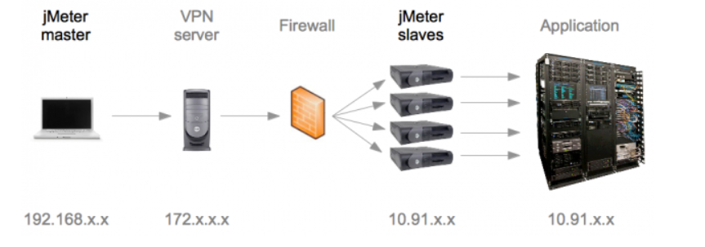

Here we can create n number of slaves based on the requirement, and will take IP address of those slaves and will pass those IP address into the JMeter.Properties file in master machine.
2.Jmeter.Properties file settings
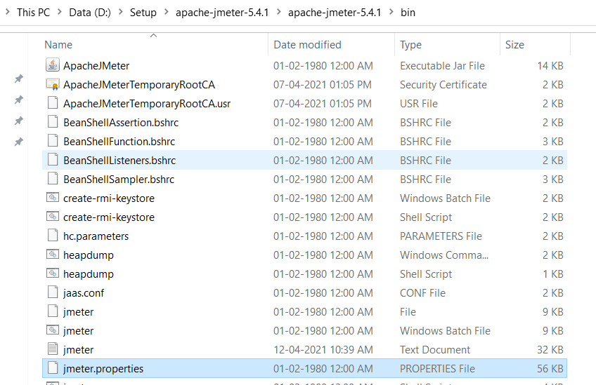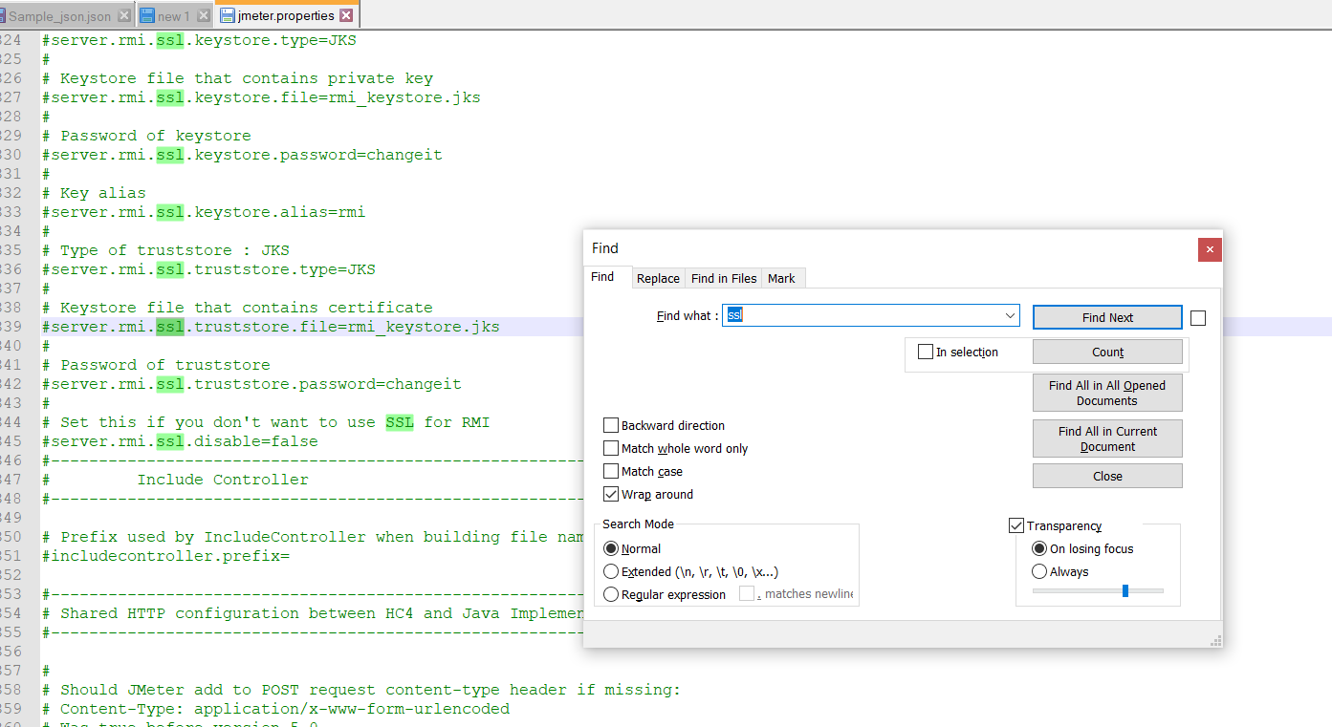
3.Uncomment below selected line and change value to true
